1. For 128 Byte Packet size :
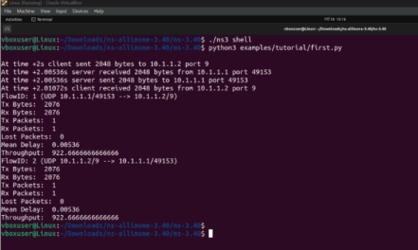
2. For 256 Byte Packet size :
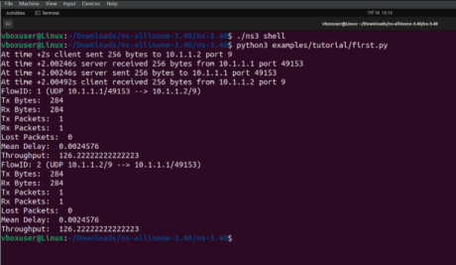
3. For 512 Byte Packet size :
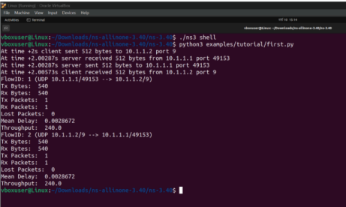
4. For 1024 Byte Packet size :
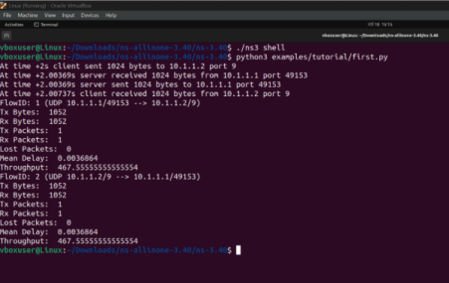
5. For 2048 Byte Packet size :
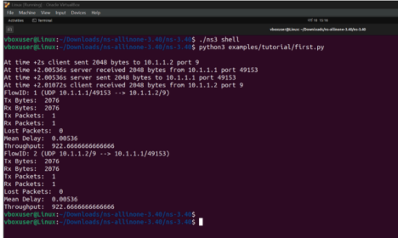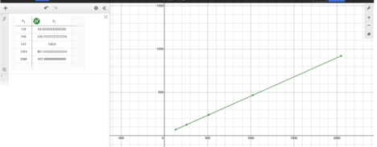
Graph: Plot of Packet Size vs. Throughput
In this graph, Throughput—the dependent variable—is shown on the Y-axis, while Packet Size, the independent variable, is plotted on the X-axis. By adjusting the packet size in the code for each run, we can observe that throughput generally increases as the data size grows.

